Architectural Review Checklist

caLAB
0.5

Revision Document History
Date | Version | Description | Author
02/6/06 | 1.0 | First draft | NCICB Dedicated Support

Table of Contents
1. Introduction 6
1.1 Purpose 6
1.2 Guidelines for Completing the ARC 6
2. Project Details (To be answered by development team) 6
2.1 General Information 6
2.1.1 Project Description 6
2.1.2 Contact Information 6
2.1.3 Major Deployment Milestones 6
2.2 Architectural Details 7
2.2.1 High level architectural description: 7
2.2.2 High Level Design Diagram (If available): 7
2.2.3 Implementation language(s) used? 7
2.2.4 Will connections/requests to the application be session based (i.e. statefull versus stateless)? If so, is there any reason why application would not support “sticky session” load balancing? 7
2.2.5 Will the application be caching data? If so, what is being cached and how much data will be cached? 7
2.2.6 What data files will be created (if any)? How much data will be saved on an on going basis? 7
2.2.7 Will this application need a database schema(s) created on the NCICB infrastructure? If so, what is the maximum number of objects to be stored? 7
2.2.8 Are there any external/non-NCICB data sources that will be accessed by the application? 7
2.2.9 If this is a web-based application, what are the preferred virtual hosts names to be registered? 7
2.2.10 Any additional architectural details that may be of significance to the needed deployment environment. 7
2.3 Performance Requirements 8
2.3.1 Total number of users for this application? 8
2.3.2 Peak number of concurrent users? 8
2.3.3 Peak number of requests/minute? 8
2.3.4 Up time requirements? 8
2.3.5 Acceptable down time when recovering from major systems disaster? 8
2.4 NCICB Project Dependencies 8
2.5 Configuration Management Details 8
2.5.1 Version Control 8
2.5.2 Change Control 8
2.5.3 Migration to CVS 8
2.5.4 Users 8
2.5.5 Build Process 8
2.5.6 Other CM Needs 8
2.6 Additional Notes 8
3. System Requirements (To be answered by both development & systems team) 9
3.1 Operating System 9
<<Solaris/LINUX/Windows 2000/…>> 9
3.2 Software (Technology Stack) 9
3.2.1 Web Server: <<Apache/Tomcat/ZOPE/…>> 9
3.2.2 App Server: <<Tomcat/JBoss/Oracle 9iAS/…>> 9
3.2.3 Database Server: <<Oracle/MySQL/PostgreSQL/…>> 9
3.2.4 Other software components: <<PERL x.x, Python x.x, …>> 9
3.3 Server Hardware 9
3.3.1 Server: <<type, model, …>> 9
3.3.2 Minimum processor speed: 9
3.3.3 Minimum memory: 9
3.3.4 Minimum local drive space: 9
3.4 Storage 9
3.4.1 Expected file server disk storage (in MB): 9
3.4.2 Expected database storage (in MB): 9
3.4.3 Expected ftp storage (in MB): 9
3.4.4 Expected media/image storage (in MB): 9
3.5 Load Balancing/Fault Tolerance 9
3.5.1 Does the application support load balancing? 9
3.5.2 Implement load balancing – YES/NO 9
3.6 Networking 9
3.6.1 Any application specific port assignments? 9
3.6.2 Any additional configuration? 9
3.7 Additional Notes 9
4. Proposed NCICB Deployment Environment (To be answered by systems team) 9
4.1 Hardware 9
4.2 Technology Stack 10
4.3 File Server 10
4.4 Database 10
4.5 Networking 10
4.6 Other Resources 10
5. Impact Assessment (To be answered by systems team) 10
5.1 Overview 10
5.2 Cost 10
5.3 Timeline to implement 10
5.4 Additional Notes 10
6. Acceptance 10
7. Appendix 1 - Future Systems Requirements 11
7.1 New Architecture Diagram 11
7.2 Notes on the design change 11
7.3 Hardware 11
7.3.1 Servers 11
7.3.2 Processor speed 11
7.3.3 Memory 11
7.3.4 Drive Space 11
7.4 Software (Technology Stack) 11
7.4.1 Web Server 11
7.4.2 App Server 11
7.4.3 Other components 11
7.5 Fault Tolerance (Redundancy) 11
7.5.1 Does the application support load balancing? 11
7.5.2 Implement load balancing – YES/NO 11
7.5.3 Load balancing requirements 11
7.5.4 Fault tolerance solution suggested 11
7.5.5 Additional requirements (if any) 11
7.6 Performance Enhancements 11
7.6.1 Processing Power 11
7.6.2 Memory 11
7.6.3 I/O 11
7.6.4 Other needs 11

Introduction

Purpose
The purpose of the Architectural Review Checklist (ARC) is to help identify the deployment environment (both hardware and software components) necessary for an application to execute optimally within the NCICB IT infrastructure. The ARC is considered to be a dynamic artifact for any NCICB project and should be maintained in the configuration library (i.e. CVS) for each project. For new projects, this document template will be automatically checked into the projects repository by the SCM team upon project initiation. The ARC should be reviewed on at least a quarterly basis to capture any application design changes that may effect the deployment environment necessary for optimal performance.

Guidelines for Completing the ARC
The ARC is divided into 4 main sections. The first section (Project Details) is meant to capture general information about the project. The project development team should fill out the Project Details section and return it to the systems team. The second section (Systems Requirements) is meant to capture details of specific system requirements for the project. Both the development and system teams will preferably answer the Systems Requirement section jointly. However, depending on the development teams familiarity with the NCICB infrastructure, they may choose to answer either all or parts of this section on their own. The third section (Planned Deployment Environment) specifies the proposed deployment environment for the application and is to be answered by the systems team based on the response to section 1 & 2. Finally, the last section (Impact Assessment) describes the impact (additional hardware/software costs, staffing resources…) to the existing NCICB IT infrastructure in order to support this application. Upon completion of the Deployment Environment and Impact Assessment sections, the systems team will return the ARC to the development team for final review and comments.

Project Details

General Information

Project Description
The cancer Laboratory Analysis Bench (caLAB) effort involves the design and development of core components of a caBIG compatible Laboratory Information Management System (LIMS). The effort also involves the deployment of a reference implementation of a core caLAB for operation in the Nanoparticle Characterization Laboratory (NCL). As such, the effort involves the development of core LIMS functionality that is of priority to the NCL with an understanding that prioritized NCL needs are also core LIMS features.

Contact Information
Title | Name | Phone | Email
Project Manager | TBD - Full-time PM  Sharon Settnek – Part-Time | 301.451.6345 | settneks@mail.nih.gov
Team Lead/Architect | Jennifer Zeng – Tech Lead | 301.594.4761 | zengje@mail.nih.gov
SCM Coordinator | Sashi Thangaraj – Architect | 301.402.4275 | thangars@mail.nih.gov

Major Deployment Milestones
Milestone | Date
Planned Release to QA | Mid March
Planned Release to Staging | Late March
Planned Release to Production | Late March/Early April

Architectural Details

High level architectural description:
caLAB is an N-tier Web application built using JSF and Hibernate. The presentation layer uses JSP, Tag libraries and other presentation objects. Business layer consists of caLAB DTOs and utility objects. Persistence layer that follows business layer consists of caCORE SDK components and Hibernate to interface with the data base or Network file system.
The https request from a client browser is detected at the Presentation layer and then is converted into a object request using DTOs at the business layer and this request is parsed and executed at the persistence layer against the corresponding data source – data base or file system. Object to Relational Mapping (ORM) is done using hibernate. The security of the application is taken care by CSM.

High Level Design Diagram (If available):
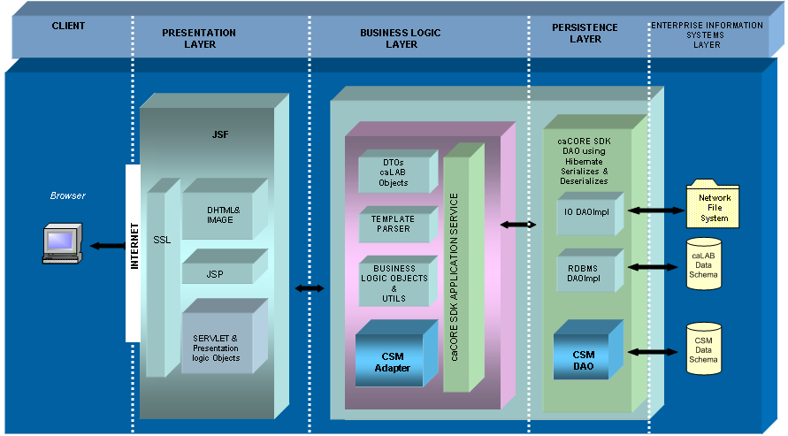

Implementation language(s) used?
Java, HTML/JSTL tags for presentation layer.

Will connections/requests to the application be session based (i.e. statefull versus stateless)? If so, is there any reason why application would not support “sticky session” load balancing?

Connections are “statefull”. No known reason why sticky session load balancing cannot be used, but it would need to be thoroughly tested before production deployment.

Will the application be caching data? If so, what is being cached and how much data will be cached?

No known reason why we need to cache the data however in the future iterations this may be desired.

What data files will be created (if any)? How much data will be saved on an on going basis?

caLAB application allows users to upload variety of instrument generated file types starting from image to other binary types. A typical caLAB instance in NCL may approximately upload 100 gigabytes of data files. This number might change as the LAB starts to get more experiments.

It is anticipated that the final production version of caLAB will be deployed in Frederick at the ABCC. Consequently, the ABCC will be responsible for providing production level file and data storage.

Will this application need a database schema(s) created on the NCICB infrastructure? If so, what is the maximum number of objects to be stored?

Yes. The current database schema will have less than 20 objects which might hold less than 0.5 million rows of data. The database will have more data added, in future releases.

Are there any external/non-NCICB data sources that will be accessed by the application?

No.

If this is a web-based application, what are the preferred virtual hosts names to be registered?

calab.nci.nih.gov [generic calab for demonstration and download purposes]
ncl-calab.nci.nih.gov [NCL reference implementation of calab]

Any additional architectural details that may be of significance to the needed deployment environment.

Using CSM for authentication and SDK for basic architecture.

Performance Requirements

Total number of users for this application?

Approximately ~30 user accounts to the first iteration of the NCL reference implementation of caLAB.

Peak number of concurrent users?

Internally we expect 10 concurrent hits.

Peak number of requests/minute?

Less than 25 for the first iteration; however future releases may require more hits.

Up time requirements?

Desired 24/7, but this is not a mission critical application, and estimate that the general usage times will be 6 a.m. – 10 p.m.

Note: The production version of the NCL reference implementation will be deployed at the ABCC in Frederick; however, a demo version of caLab should be available on the NCICB servers for demo purposes.

Acceptable down time when recovering from major systems disaster?
24 hours probably in a weekend.

NCICB Project Dependencies
caCORE SDK, CSM, and EVS

Configuration Management Details
Briefly describe your current configuration management practices here.

Version Control
What version control software are you currently using, if any?
CVS

Change Control
What are your current change control practices? What procedures are in place to determine whether to implement a change request?
The caLab project is being implemented via an iterative process. Iteration 1 will contain minimal functionality, which will be expanded in later iterations (July). After July when caLab 1.0 is completed, a robust end user change control process will be put in place. Change control in pre-1.0 will be implemented via direct communication with the NCL representatives at monthly meetings and throughout the course of the effort. The NCICB will set priorities based on end user requirements.

Migration to CVS
Indicate whether you will require SCM support migrating your source code to the NCICB CVS repository.
N/A

Users
Provide a list of all developers who require access to your repository modules.
Anand Basu
Clifford Robert
Jenny Kelley
Sharon Settnek
Sashi Thangaraj
Doswell Jayfus
Jeniffer Zeng
Sue Pan
Linda Molnar

Build Process
Describe your build process here. For example, are you using Ant, Make, or something else?
Ant

Other CM Needs
Describe any other CM needs?

Additional Notes

System Requirements

Operating System

Solaris
Is Linux available?

Software (Technology Stack)

Web Server: Apache

App Server: JBoss 4.0.2

Database Server: Oracle

Other software components: Java 1.5.04

Server Hardware

Server: <<type, model, …>>

Minimum processor speed:

Minimum memory:

Minimum local drive space:

Storage

Expected file server disk storage (in MB):

Expected database storage (in MB):

Expected ftp storage (in MB): 0.0

Expected media/image storage (in MB):0.0

Load Balancing/Fault Tolerance

Does the application support load balancing? Not tested

Implement load balancing – YES, depending on results of testing.

Networking

Any application specific port assignments? NO

Any additional configuration? NO

Additional Notes

Proposed NCICB Deployment Environment (To be answered by systems team)

Hardware
<<dev, qa, staging, production servers to be used>>

Technology Stack
<<specific technology stack to be used>>

File Server
<<space allocation on big IP, NFS mount points, initial size allocation…>>

Database
<<database server to used, schema names to be created, initial size, maximum size…>>

Networking
<<e.g. any BigIP configuration necessary, …>>

Other Resources
<<e.g. ftp server access, media server access, …>>

Impact Assessment (To be answered by systems team)

Overview

Cost

Timeline to implement

Additional Notes

Acceptance
Project Lead ( ) | Project Coordinator – NCICB ( )
Systems Team | SCM Administrator

Appendix 1 - Future Systems Requirements
In this section, describe any projected future anticipated requirements for your system.

New Architecture Diagram

Notes on the design change

Hardware

Servers

Processor speed

Memory

Drive Space

Software (Technology Stack)

Web Server

App Server

Other components

Fault Tolerance (Redundancy)

Does the application support load balancing?

Implement load balancing – YES/NO

Load balancing requirements

Fault tolerance solution suggested

Additional requirements (if any)

Performance Enhancements

Processing Power

Memory

I/O

Other needs

